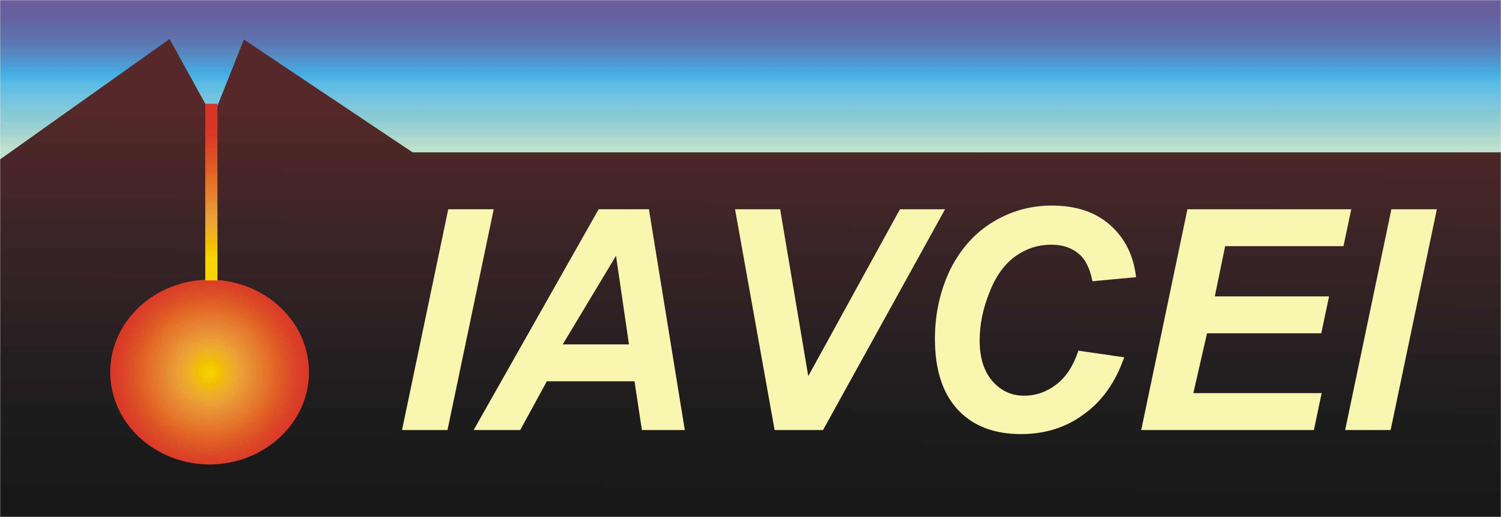
International Association of Volcanology and Chemistry
of the Earth's Interior (IAVCEI)

An Association of the International Union of Geodesy and Geophysics

Bari, March 10, 2016

FINANCIAL SUPPORT REQUEST TO IAVCEI
Obligations and benefits

To sign the IAVCEI financial request form implies the acceptance of the following obligations:

- All the participants to the meeting, conference, workshop or school must be IAVCEI members. If not currently IAVCEI members, participants can either become members or pay an additional equivalent fee at the time of registration that will be subsequently transferred from the organisers to IAVCEI. Information on membership fees can be found on IAVCEI website (www.iavcei.org).
- The organisers have the responsibility to check the inscription of the participants for the year in which the event is financed, eventually asking for the collaboration of the IAVCEI webmaster and SG.
- The membership fees paid at inscription to the sponsored event need to be transferred to the IAVCEI before the start of the event.
- Financial and scientific reports have to be sent to IAVCEI at the end of the financed event

The acceptance of the above rules allows:

- The official endorsement of IAVCEI
- The permission to use of IAVCEI logo in official documents and brochures
- The announce of the event on IAVCEI website
- Announcement of the event through the IAVCEI mailing list

We, the signatories, as applicants for IAVCEI support, agree with these rules and procedures.

Date Signature

The form needs to be returned via e-mail to Roberto Sulpizio, IAVCEI Secretary General: roberto.sulpizio@uniba.it

